Iceland Itinerary

17th | 18th | 19th | 20th | 21st | 22nd | 23rd
Leg 1 17-18th
https://maps.app.goo.gl/YPtKLQH5mSjuPk9r9
Leg 2 18th-20th
https://maps.app.goo.gl/cdRV1jRqoSbKfKxv8
Leg 3 20-21st
https://maps.app.goo.gl/skcPZegq6LLhtCk39
Leg 4 21st-23rd (End)
Short - https://maps.app.goo.gl/FnX1Q7cG9pU1nV279
Long - https://maps.app.goo.gl/T852s7zPMyxfZh6Z7

Cars
https://www.hertz.is/?step=search-result

https://www.calcmaps.com/map-distance/

Camsites
Gas Stations

Flights - Jose
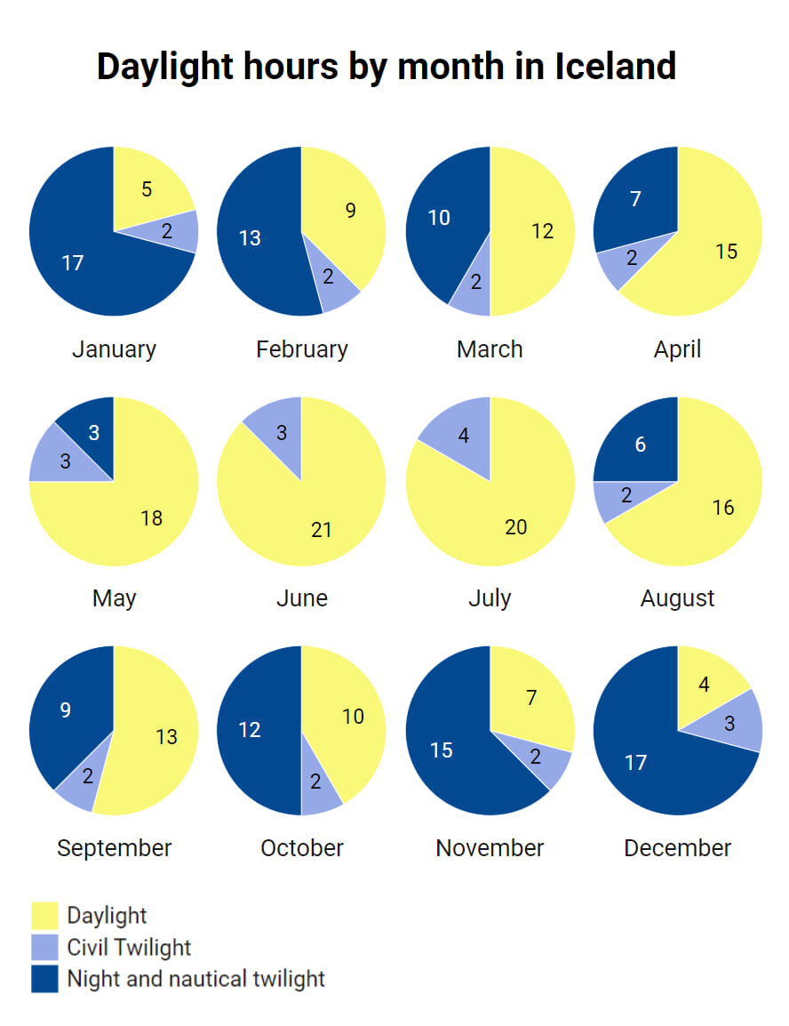
midnight in iceland in july

